What is the output ?

reduce **will** iterates over the array – Function will accumulate each length 0 + current length of each string ( 0 + 8 + 10 + 9) = 27

**forEach will** iterates over the array – myFunction will multiply each number * 10 and return a new array contains the new numbers [650 , 440 , 120 , 40]

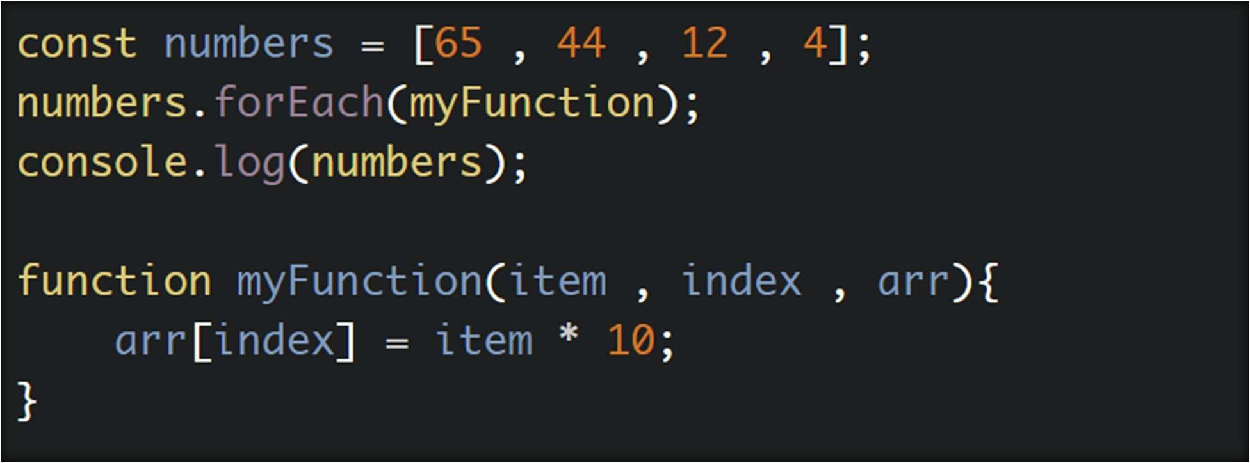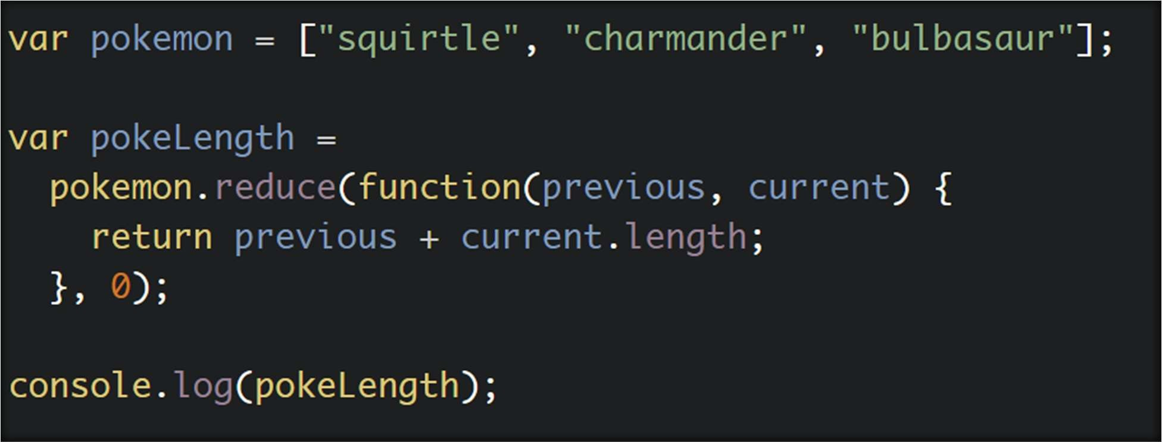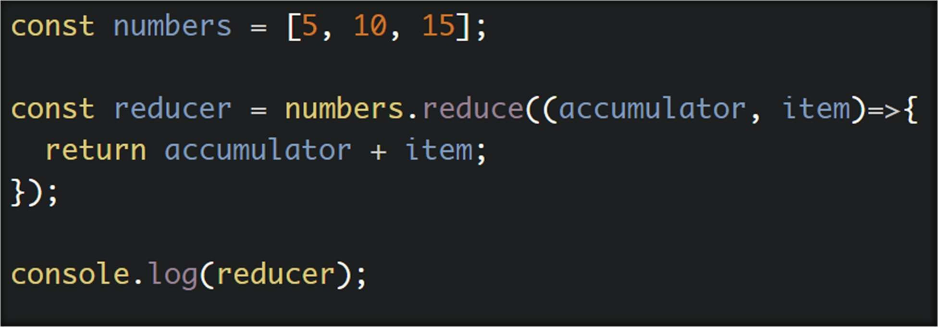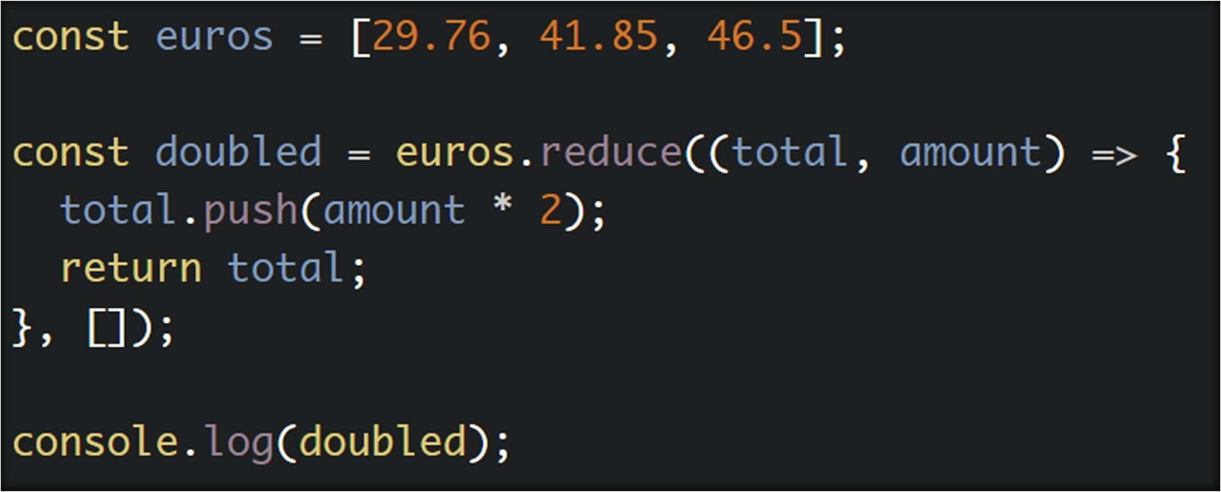

reducer **will** iterates over the array – Function accumulator will accumulate the numbers on the array (5 + 10 + 15) = and show the result = 30

doubled **will** iterates over the array – push will make another array after multiply each value by 2 and make a new array contains the new doubled numbers

includes **will** iterates over the array and check if 2 and 99 included on the array or not and print the result True or False   
1st result is True   
2nd is False

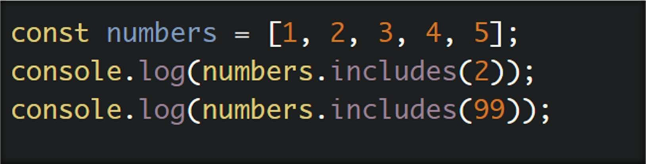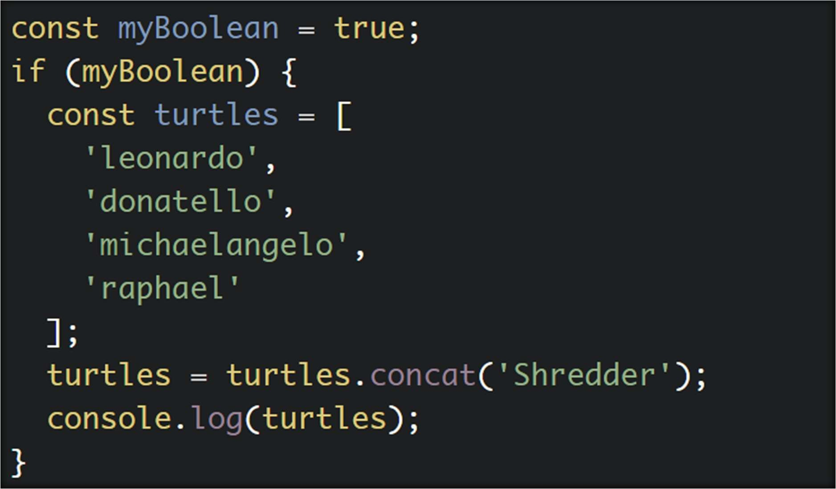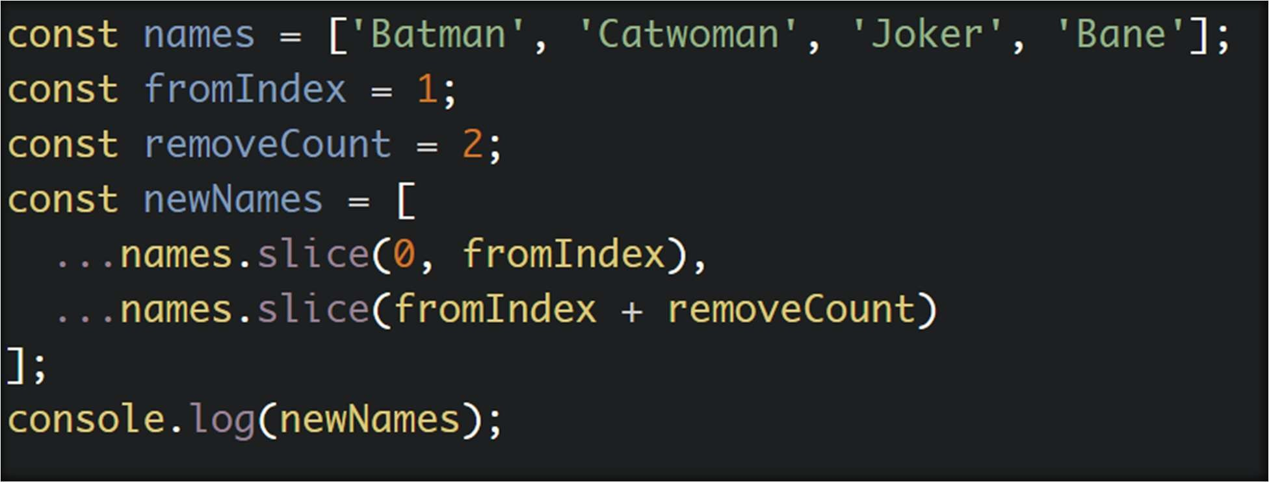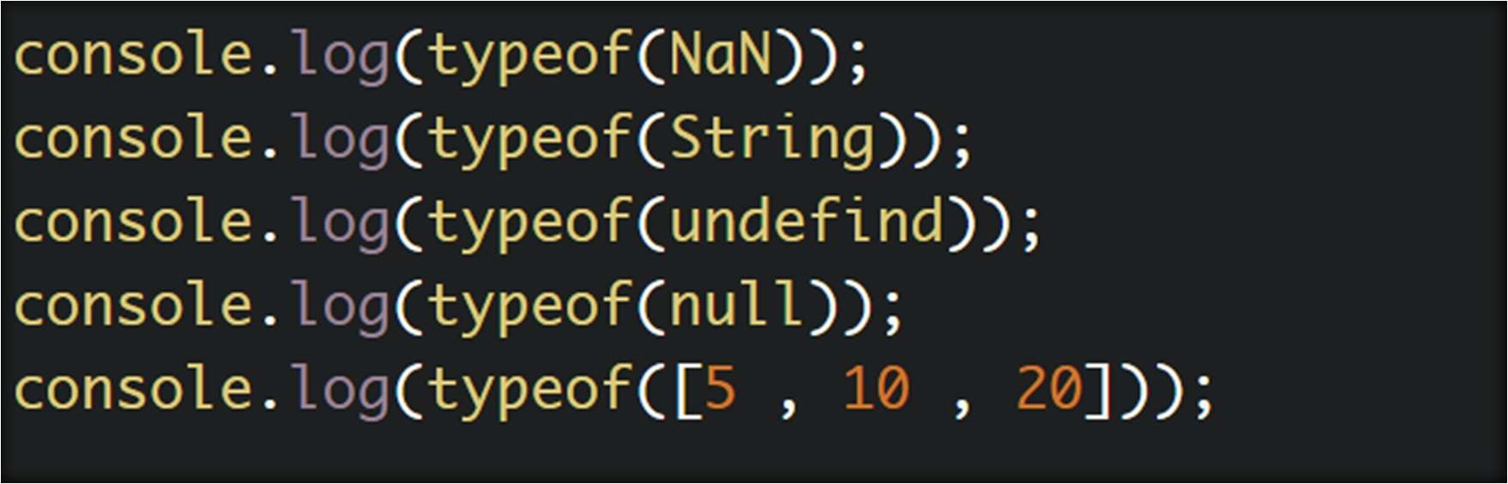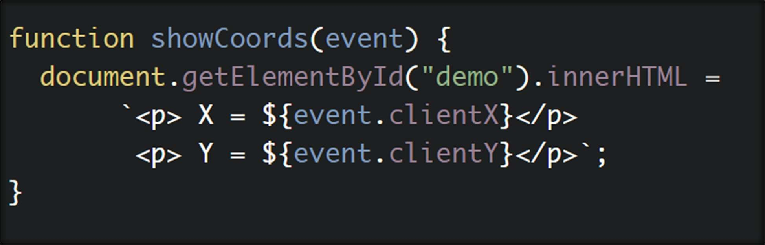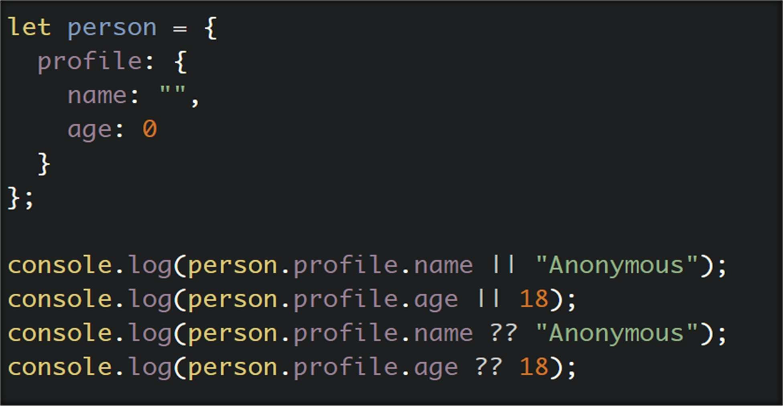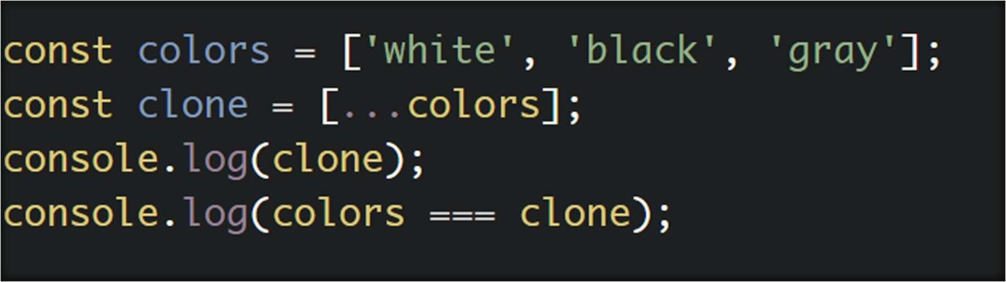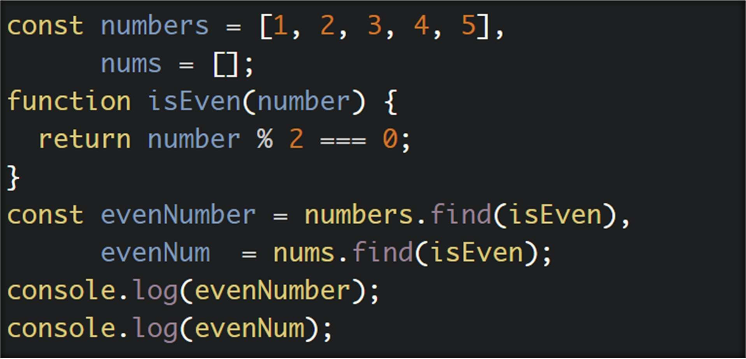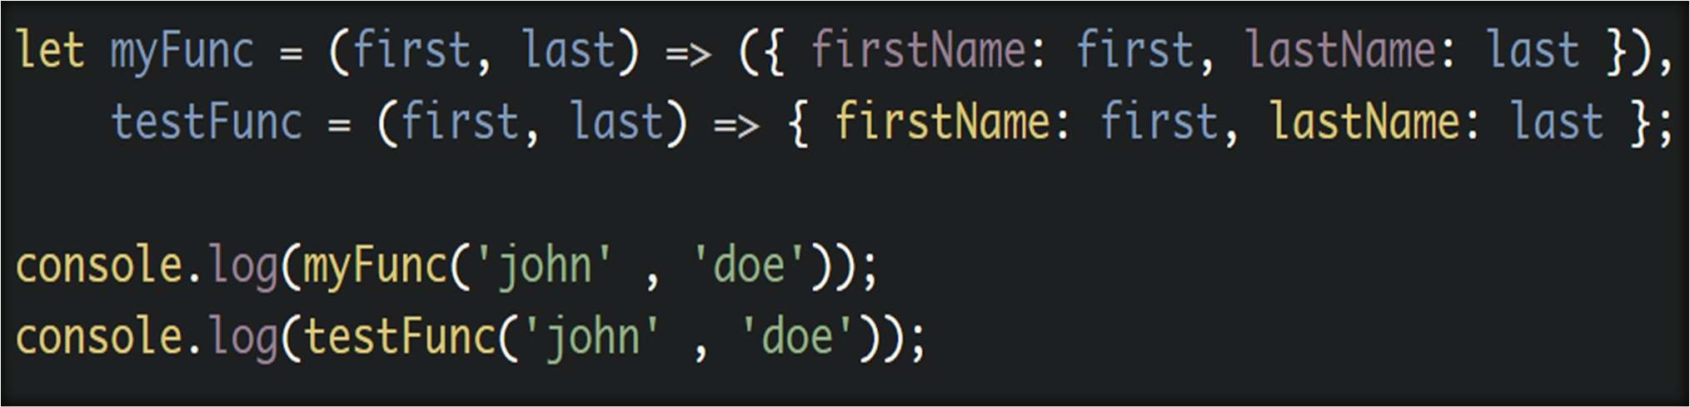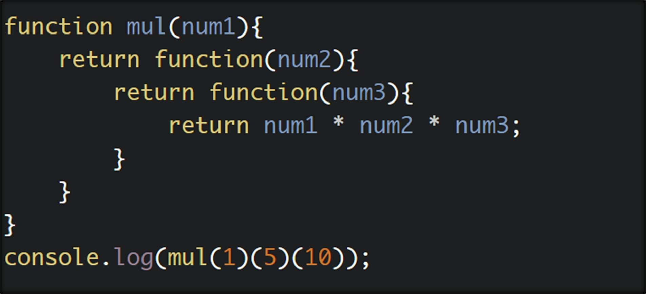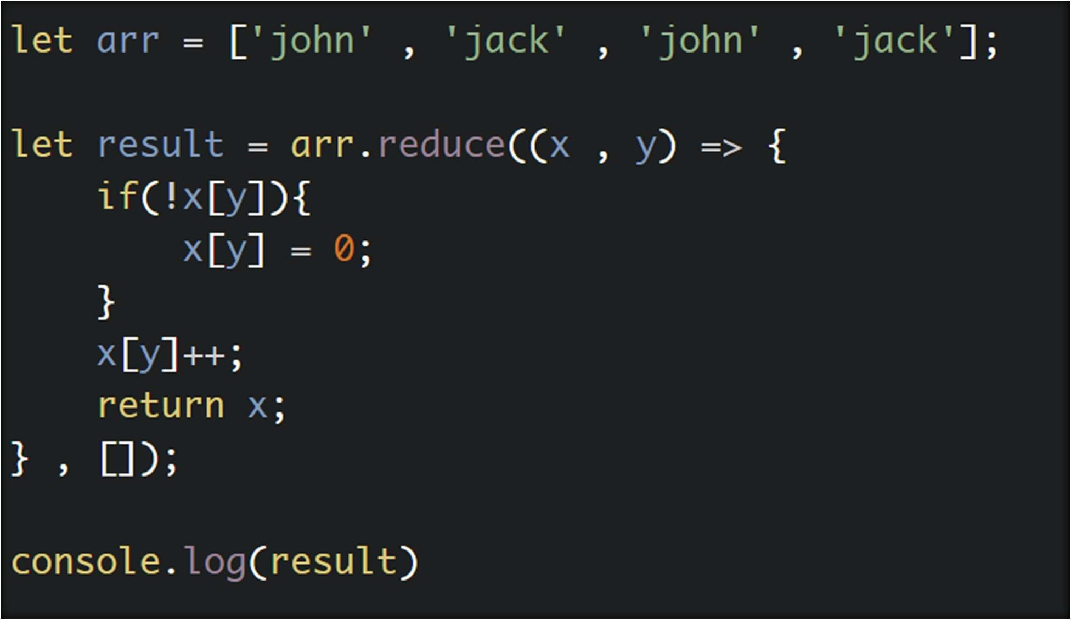

Good Luck ◆:v

By : Eng Hesham Mohamed